Exercise

Exercise 01

- Start Debug by typing Debug and hitting return. The indicator that you are in debug will be a “dash”or “hyphen”: - . Debug commands are entered after the dash. For example, when you want to quit Debug you enter a Q (for quit) after the dash.

- The command to examine the content of registers is This will display the content of all the registers, in hex, as follows:
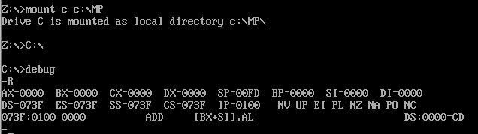

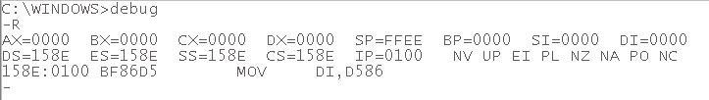

Exercise 02

Use the R command to view the register contents for your machine. Record the results:

AX: SP:
DS: IP:
BX: BP: ES:
CX: SI:
SS:
DX: DI:
CS:

You can change the 16-bit content of a register or the flag bits by following the R command with the register you want to change. (Be very careful about changing the segment registers because that will affect where your program runs or your data is contained.)
-R AX will respond with the present value of AX and then allow you to enter a new 4-digit hex number for its content. You cannot change only 8-bits, i.e., -R AH is not allowed.

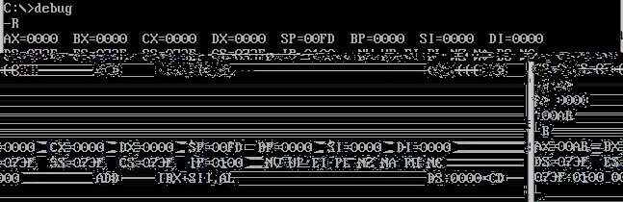

Exercise 03

Change AX to 1234h and use –R to verify that the change occurred. AX----

Exercise 04
Enter –R f and see that all the flag values are given. You can make changes by entering the new literal codes for the flags you want to change in any order. Change the sign and auxiliary carry to be the opposite of what is presently shown and verify the change was made.
The one-bit flags are shown by a literal code. Starting from the left the flags are:
 | Set (1) | Clear(0) Your Flags:
Overflow | OV (yes) | NV (no)
Direction | DN | UP
Interrupt enable | EI | DI (disabled)
Sign | PL | NG
Zero | ZR | NZ
Aux. Carry | AC (yes) | NA
Parity | PE (even) | PO (odd)
Carry | CY | NC
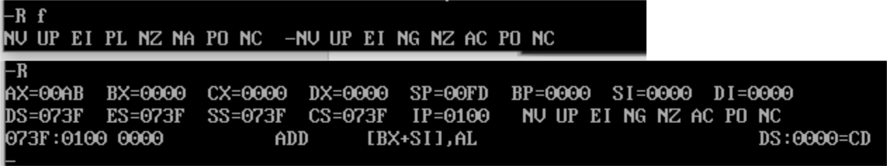

Exercise 05

Suppose you want to change only CL to FFh but CH should keep the same value. Explain how this can be done, do it and verify your results.Use the concept of MSB and LSB to change the values.
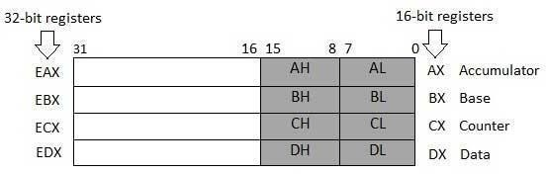

Exercise 06

Before: CX = so CL = and CH = AfterS: CX = so CL = and CH =

- Now change only DH to 33h but do not change DL. Verify using –R.
- Elaborate the positions of LSB and MSB . Give example of each.
- Why Little Endian and Big Endian is used . Explain with examples.

